**Context**

I first plotted all independent variables against time to check that the data appeared to meet the assumptions of homoscedasticity. Sales, profits, and costs all appeared to be geometric/asymptotic. The graphs below illustrate the heteroscedasticity of these data (i.e., decreasing variance as time increases).







I then removed outliers, excluding observations where age was over 60 or salary was over 11,000. I next created low, medium, and high dummy conditions for the dependent salary variable and transformed all variables to log scale, including those instrumental variables described above.

**Model Stability**

The first model I ran included all instrumental and logged variables. Before discussing the heteroscedasticity of the data in this model, it is worth noting that all coefficients except those related to age were significant. I had also created an instrumental variable for the percent of a CEO’s life s/he had been leading the company (“pct_of_life”). This was removed due to collinearity with the other two age variables. Ultimately I removed all age-related variables in subsequent iterations of the model because of collinearity and insignificance.

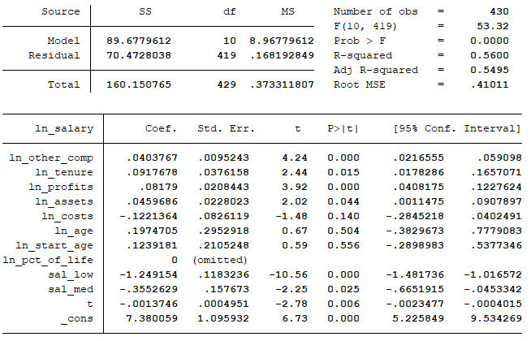

We can check the model stability by running the Breusch-Pagan test for heteroscedasticity on both sides of the regression (i.e., the dependent and independent variables separately). This reveals heteroscedasticity as a problem for both the regressors and the regressand because both p-values are significant compared to the chi-squared distribution.

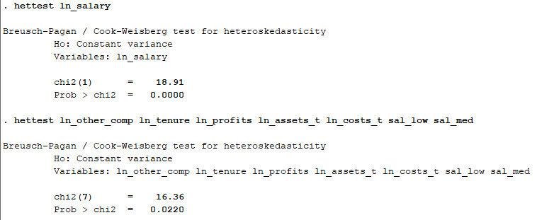

Because we do not know the function that accounts for the heteroscedasticity in the data. We have to estimate the function through feasible generalized least squares. To do this, I regressed the log of salary on the logs of other compensation, tenure, profits, assets, costs, and dummy variables for low and high salary conditions, as noted below.

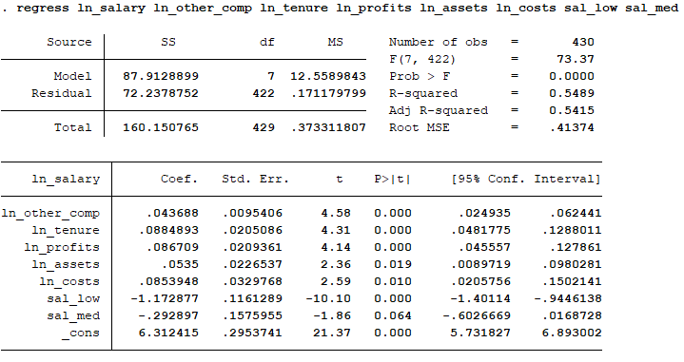

I then computed the log of the squared residuals from the regression above, and regressed the log of these squared residuals on the regressors.

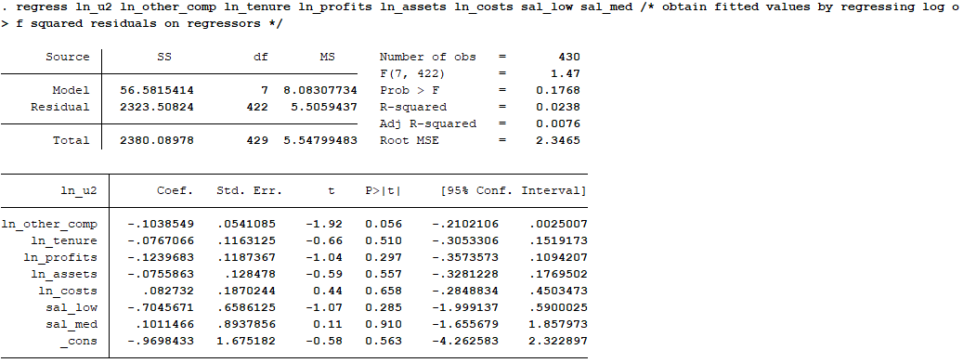

I then exponentiated these fitted values to calculate h-hat and transformed all variables by multiplying each by 1 divided by the square root of h-hat. I then performed the same regression to get the table below. Note that profits were not significant went transforming the data to account for heteroscedasticity, so I removed them from the final regression.

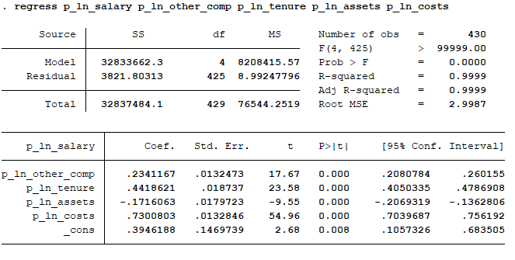

The model listed above has a Durbin-Watson d-statistic of approximately 2 (1.91). That said, the data appear not to be normally distributed because of the transformations applied (i.e., they have substantially lower variance).

I repeated this test using the data from example 8.7 in the book (pp. 288-289). This procedure did succeed in stabilizing the model (i.e., it passed the Breusch-Pagan test), though the data were also not normally distributed in this model.